Question: Mismathing bar chart stacks from DB data. Figure 1 is Data model from DB, Figure 2 is our design page

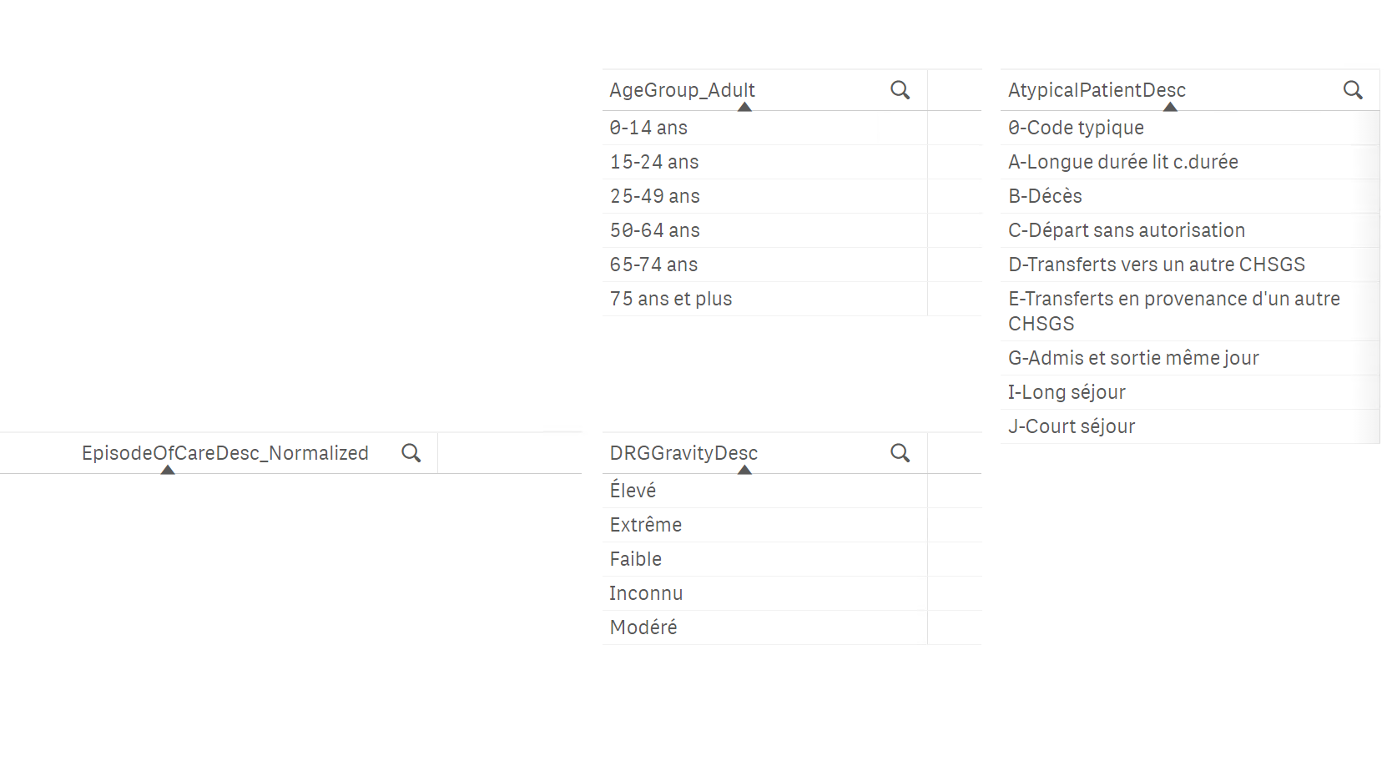

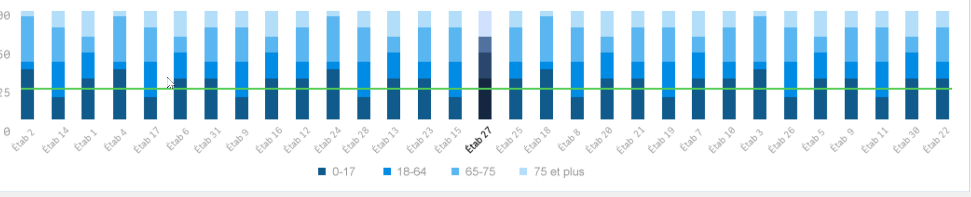

E.X

AgeGroup is grouped in different way as designed chart, as we can see, there’re 6 groups in the list in datatable, but only 4 in design chart, so two questions:

1. Which group should we follow? If we follow designed chart, @Saverio might need to recalculate the groups in DB table
2. If we follow the db data, @Nicole has to give more shades in each color themes, especially you can see from Atyp Patient, we a lot more there.
3. I seems we don’t have any options in ‘Type de coûts’ (EpisodeOfCare_Normalized), @Saverio, is that correct?

